Ops guide
Take the hack sit.

Firstly, we click on the play button at the top of the Windows PowerShell ISE to start the code.
Once the button has been clicked it tells you what to type in to start the hacking game.

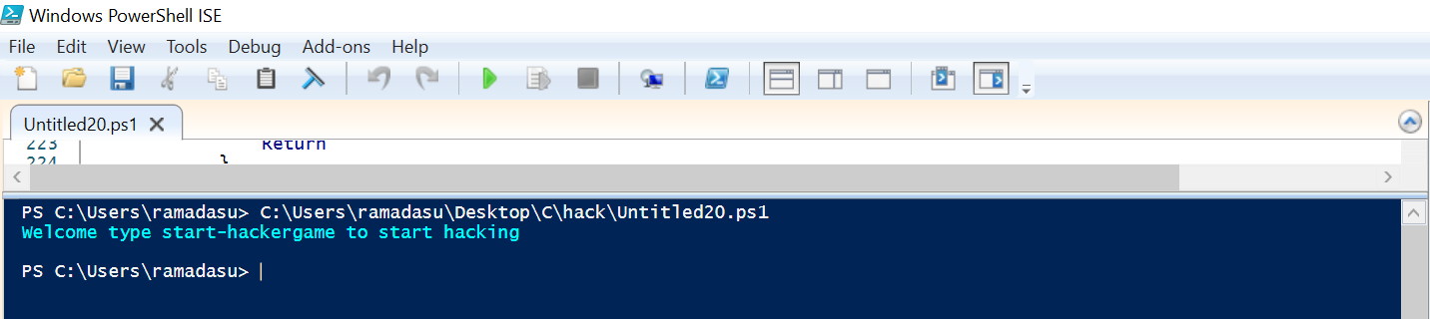

Once you type in the start-hacker game, the game begins and it prompts out the hint on how to complete the task.
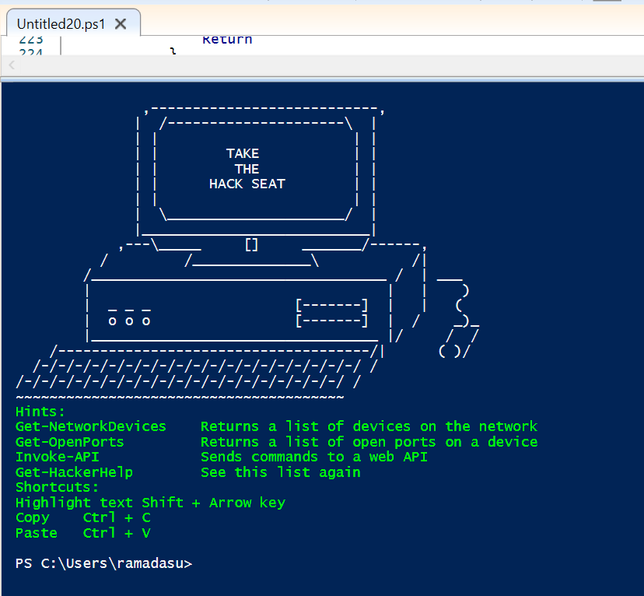
The first thing on the list is to type in Get-Network Devices. This is going to display three different IP addresses for each of the devices found. When this is done it shows scan complete.
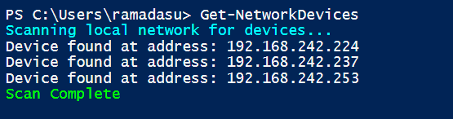

The next step is to get the port number for each one of the IP addresses. To do this we need to type the next command Get-openports then the IP address then repeat the process for the rest IP address.
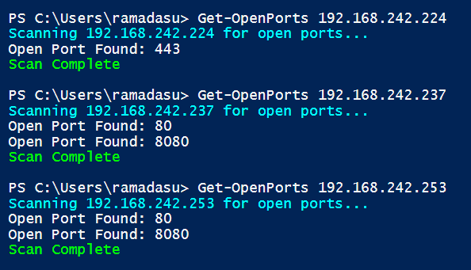

The next type is the final step, and it is tricky. The best way to approach this will be to try and error. The first thing to do is to type Invoke-API and click on enter this will display an error message that can help guide the user to complete the task. For example

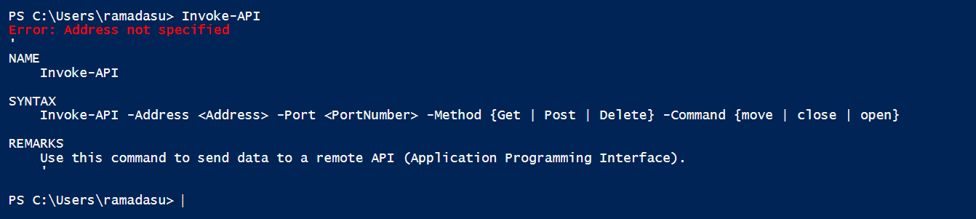

This error message tells you what needs to be added after the Invoke-API and this is:
Invoke-API -Address 192.168.242.253 -port 80 -method “you can choose between get, post and delete” -command “you can also choose between the move, close and open command”. If the IP address, port number, method, and command are correct then the task will be complete.

